

Internet Technologies Project

MTI E-Learning

**Supervised by:**

1. Dr./ *Marwa N. Refaie*
2. T.A/
3. T.A/

**Submitted by**

|  |  |  |  |
| --- | --- | --- | --- |
| N | Name | Group | ID |
| 1 | Mohamed Osama Mostafa Esmeil | 6 | 99331 |
| 2 | Mohamed Ahmed Mahmoud Ahmed | 6 | 98306 |
| 3 | Mohamed Ghonamey Hassan Ghonamey | 6 | 99400 |
| 4 | Omar Refaat Radwan Arfaa | 5 | 97701 |
| 5 | Omar Mahmoud Ahmed Khalil | 5 | 97097 |

**Table of Contents**

***Chapter 1: Introduction*** 3

1.1 Project Purpose 3

1.2 Project Scope 4

1.3 Glossary and Abbreviations 4

1.4 Core Functionalities 5

***Chapter 2: System Design and Analysis*** 6

2.1 Use-Case Diagram 6

2.2 User Flow Diagram 7

2.3 Sequence Diagram 8

2.4 Activity Diagram 9

2.5 Deployment Diagram 10

2.6 Story Map 11

2.7 Pert chart 12

2.8 Site Map 13

***Chapter 3: System UI/UX Design*** 14

***Chapter 4: System Testing*** 18

4.1 Open a course and submit an assigment 18

4.2 Valid email and password 18

# ***Chapter 1: Introduction***

### 1.1 Project Purpose

MTI University eLearning Platform is a free online learning service designed to facilitate education for our students, allowing them to access course materials and lectures on various subjects through internet-connected devices. These materials are accessible for download on iOS, Android, or Windows devices. The platform offers a diverse selection of courses curated to cater to the academic needs of our students, covering a wide array of subjects including but not limited to technology, business, arts, and sciences.

MTI University eLearning Platform is compatible with PCs, Laptops, smartphones, and tablets. For optimal performance, users can review the system requirements for web browser compatibility and adhere to recommended internet speed guidelines to ensure smooth interaction with course materials.

**Users:**

1. **Admin**

* Manage course content (add, delete).
* Monitor user activity logs and account summaries.

1. **End-Users**

* Access course lectures and materials.
* Participate in course discussions and provide feedback.
* Log in and manage their accounts.

### 1.2 Project Scope

The MTI University eLearning Platform is designed and implemented using HTML, CSS, Java Script & php, providing a dynamic and interactive website for enhanced user experience. The system encompasses both backend functionalities for data handling, validation, confirmation, and updates, as well as frontend features for user interaction with the administration and course materials. By incorporating these features, the project aims to streamline transactions, reduce processing time, and enhance overall system efficiency.

### 1.3 Glossary and Abbreviations

* **End-User:** Individuals who access and utilize the eLearning platform for academic purposes.
* **Admin:** The designated administrator responsible for managing system operations and servers.
* **Database:** An organized collection of structured information containing course materials, user data, and other relevant information.
* **SQL:** Abbreviation for Structured Query Language, a standard language for managing and manipulating databases.
* **UI/UX:** Refers to the user interface and user experience, encompassing the visual layout and interactive elements of the website that users engage with.

### 1.4 Core Functionalities

**Who is going to benefit from using the website?:**

* Students enrolled at MTI University.
* Faculty and instructors.
* Administrators overseeing academic operations.

**What benefits or value the website users get?:**

* Access to a wide range of academic courses and materials.
* Flexibility to study at their own pace and convenience.
* Interactive features such as quizzes, assignments, and discussions to enhance learning.
* Ability to track progress and manage course enrollment.
* Access to supplementary resources and materials to enrich learning experience.
* Collaboration tools for students and instructors to communicate and collaborate effectively.
* Convenient access to course materials on various devices, including smartphones, tablets, and laptops.
* Integration with external databases and APIs to provide comprehensive and up-to-date course content.
* Streamlined administrative functionalities for course management and monitoring student progress.
* Regular updates and improvements to ensure a seamless and efficient learning experience.
* Access to support services for technical assistance and academic guidance.

Overall, the MTI University eLearning Platform aims to provide a comprehensive and accessible online learning environment for students, faculty, and administrators, offering valuable educational resources and facilitating effective teaching and learning experiences.

# ***Chapter 2: System Design and Analysis***

### Use-Case Diagram

### 2.2 User Flow Diagram

### 2.3 Sequence Diagram

**Account login**

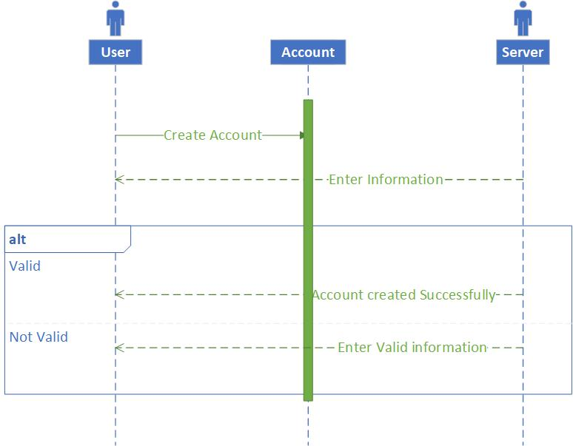

1. User input email and password
2. Server checks whether the email exists or not
3. If the account exists then create the account, otherwise shows an error message to enter a valid or new email.

### 2.4 Activity Diagram

**User Search for a course and login**

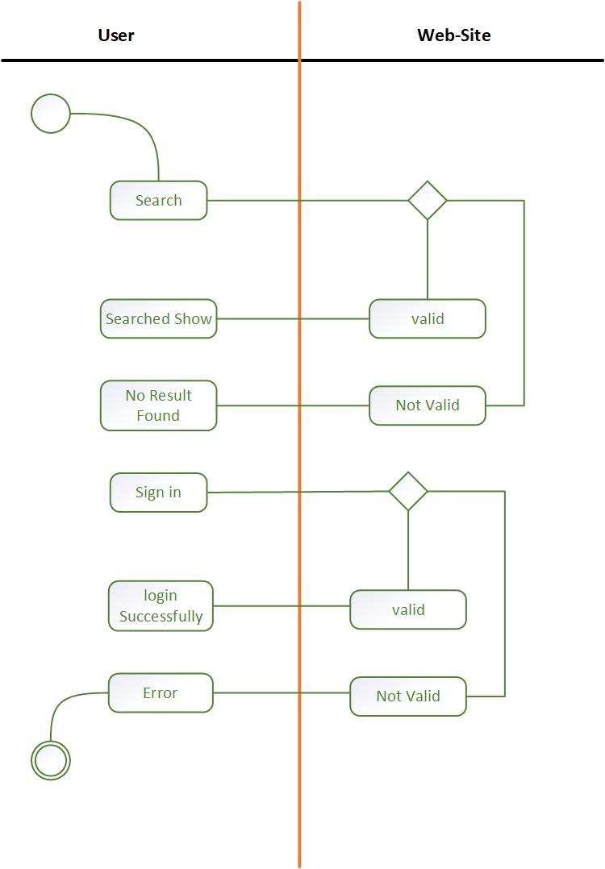

### 2.5 Deployment Diagram

Ex: **https://www.edrawsoft.com/deployment-chart-example.html**

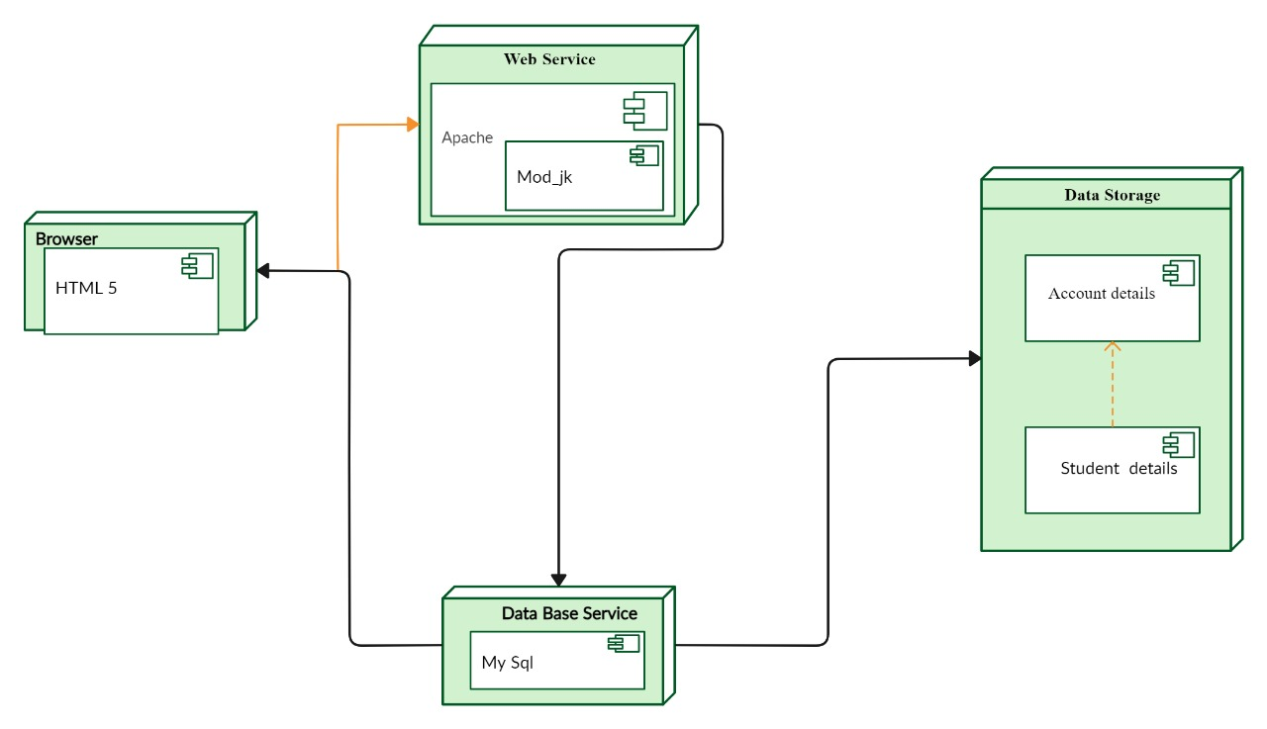

### 2.6 Story Map

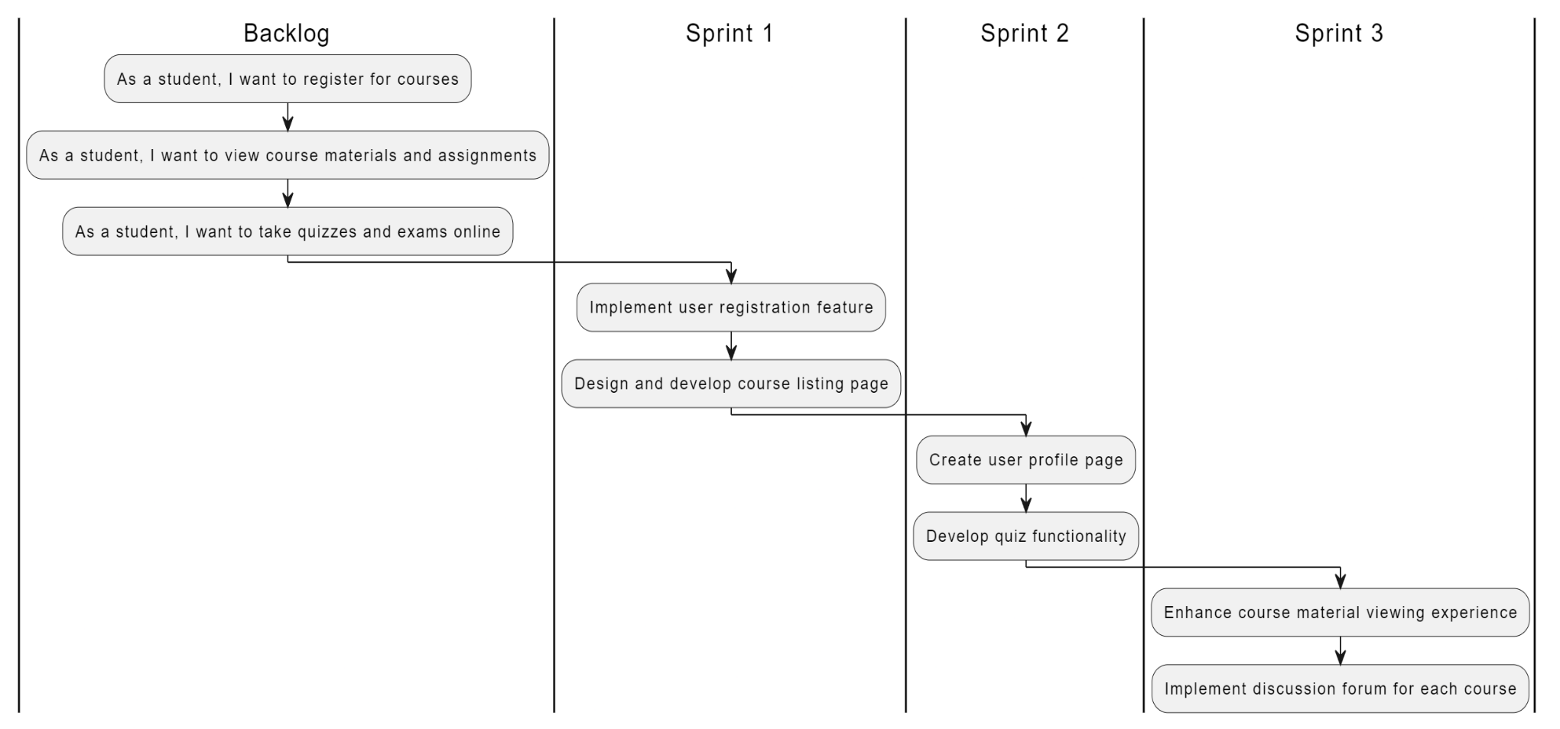

### 2.7 Pert chart

### 2.8 Site Map

# ***Chapter 3: System UI/UX Design***

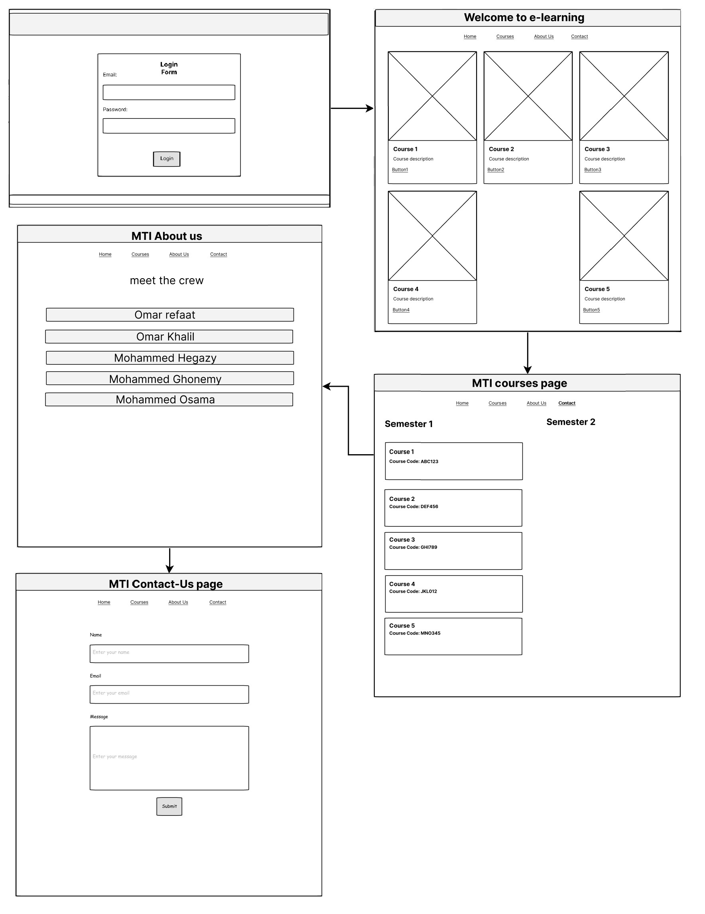**3.1 WireFrames:**

**3.2 User Interface:**

**Login Page**

**CS Home**

**Medicine Home**

**Courses Page**

**Contact Page**

**About us page**

# ***Chapter 4: System Testing***

### 4.1 Open a course and submit an assigment

|  |  |  |  |  |
| --- | --- | --- | --- | --- |
| **Test Number** | **Valid/Invalid** | **Description** | **Steps** | **Expected Result** |
| T1 | Valid | Open a course and submit an assignment. | 1. Log in to the eLearning platform. 2. Navigate to the desired course. 3. Access the assignment section. 4. Upload the assignment file. 5. Submit the assignment. | Assignment is successfully submitted. |

### 4.2 Valid email and password

|  |  |  |
| --- | --- | --- |
| **Test Number** | **Valid/Invalid** | **Description** |
| T1 | Valid email and password | End-user is logged into his/her account |
| T2 | Invalid email and/or password | The error message shown |